**CSS Assignment 1**

Q.1

<!DOCTYPE html>

<html>

<head>

    <title>CSS Question 1</title>

    <style>

        body {

            background-color: rgb(239, 249, 250);

        }

        h1 {

            background-color: #d6d8e9;

        }

        div {

            background-color: #1fe3f1;

        }

        span {

            background-color: #7380f1;

        }

    </style>

</head>

<body>

    <h1>CSS Background Colour example!</h1>

    <div>This is text inside div element.</div>

    <p> <span>This paragraph has its own background colour.</span></p>

    <div>We are still in the div element.</div>

</body>

</html>

Output:

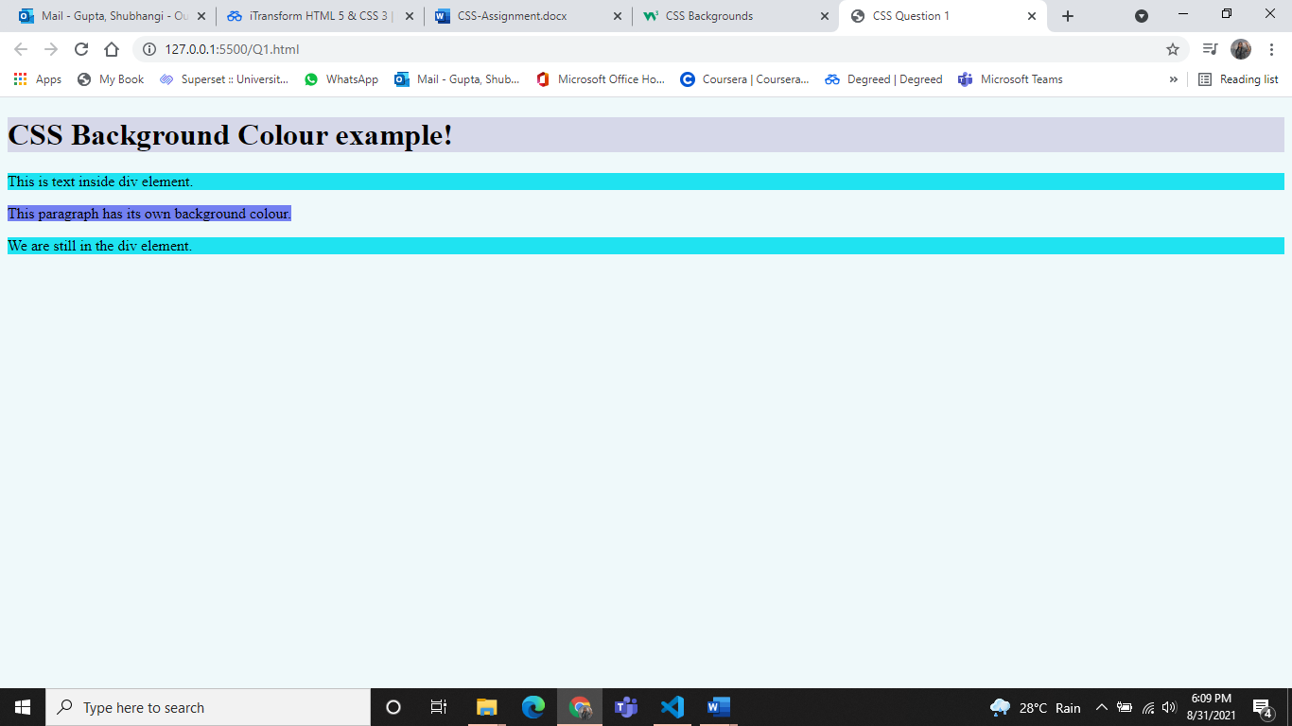

Q.2

<!DOCTYPE html>

<html>

<head>

    <title>CSS Question 2</title>

    <style>

        body {

            background-color: #cae7eb;

        }

        h2 {

            text-decoration: line-through;

        }

        h3 {

            text-decoration: underline;

        }

    </style>

</head>

<body>

    <h1>This is heading 1</h1>

    <h2>This is heading 2</h2>

    <h3>This is heading 3</h3>

    <h4>This is heading 4</h4>

</body>

</html>

Output:

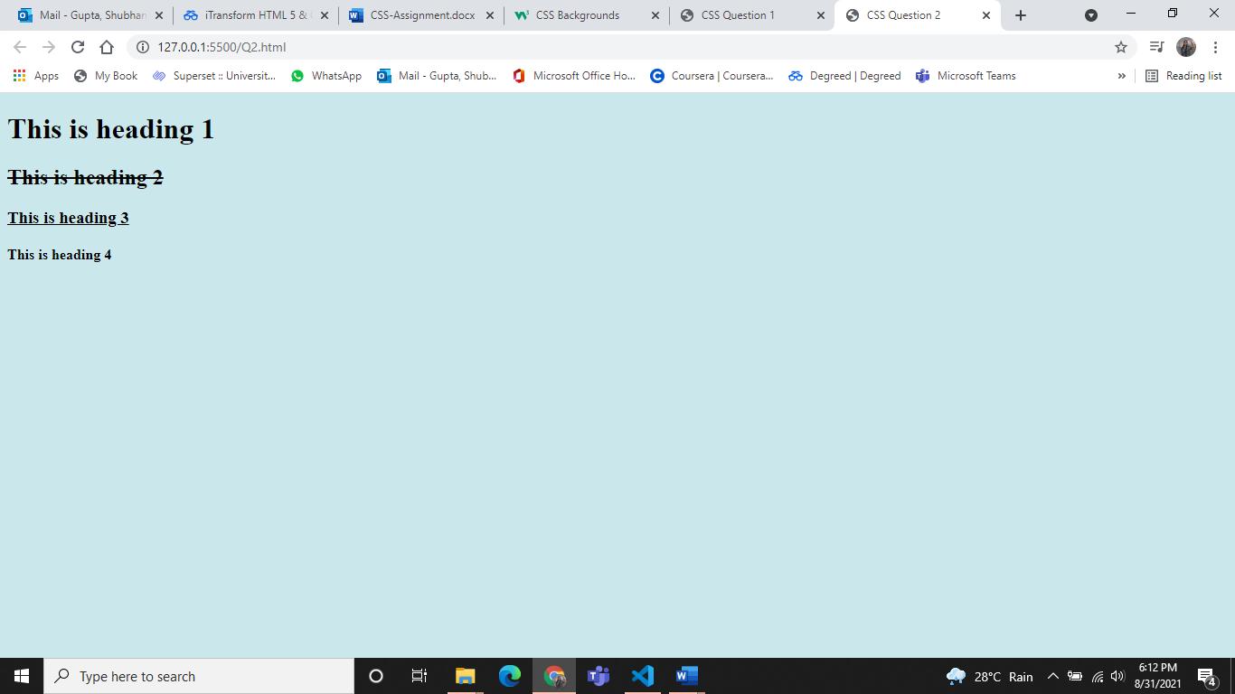

Q.3

<!DOCTYPE html>

<html>

<head>

    <title>CSS Question 3</title>

    <style>

        body {

            background-color: #c0e9ee;

        }

        div.a {

            text-transform: uppercase;

        }

        div.b {

            text-transform: capitalize;

            line-height: 2.0;

        }

        div.c {

            text-transform: lowercase;

            line-height: 2.0;

        }

    </style>

</head>

<body>

    <div class="a">this is some text.</div>

    <div class="b">This is some text.</div>

    <div class="c">This is some text.</div>

</body>

</html>

Output:

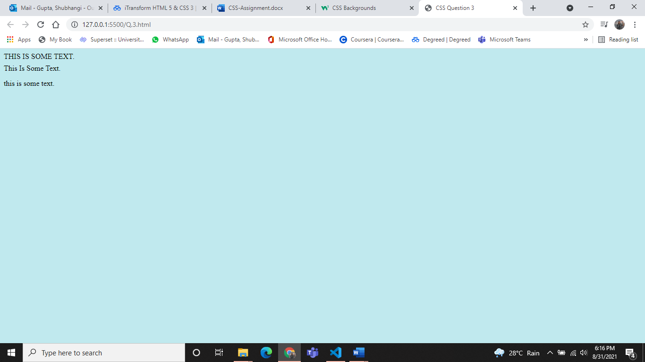

Q.4

<!DOCTYPE html>

<html>

<head>

    <style>

        /* unvisited link */

        a:link {

            color: rgb(255, 0, 0);

        }

        /* visited link */

        a:visited {

            color: rgb(98, 0, 128);

        }

    </style>

</head>

<body>

    <h2>Welcome to CSS Links</h2>

    <p><b><a href="Hello.html" target="_blank">This is a link</a></b></p>

    <p>Hello welcome to the visited link.</p>

</body>

</html>

Hello.html

<!DOCTYPE html>

<html>

<head>

    <style>

        /* unvisited link */

        a:link {

            color: rgb(4, 0, 255);

        }

        /* visited link */

        a:visited {

            color: rgb(243, 21, 21);

        }

    </style>

</head>

<body>

    <h2>Welcome to CSS Links</h2>

    <p><b><a href="Q4.html" target="_blank">This is a link</a></b></p>

    <p>Hello welcome to the unvisited link.</p>

</body>

</html>

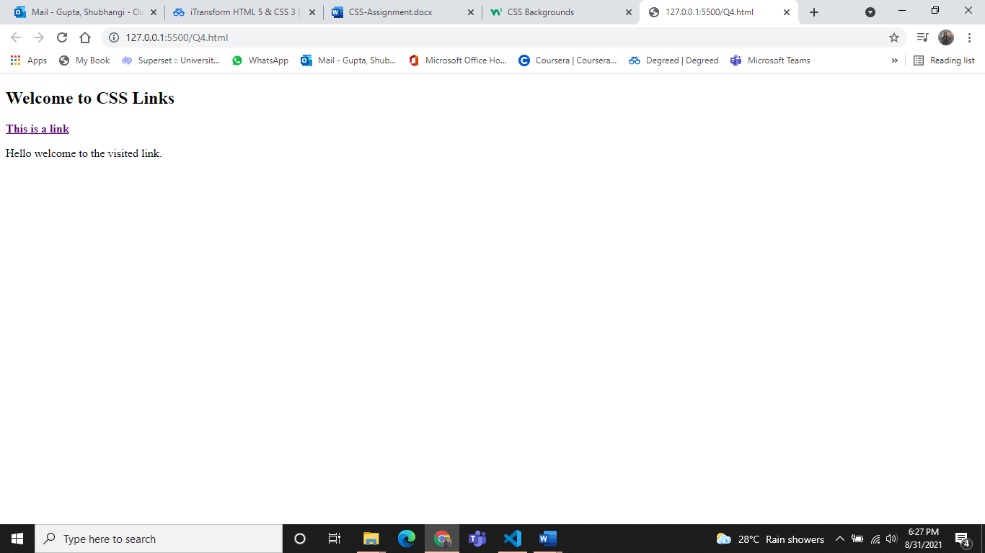

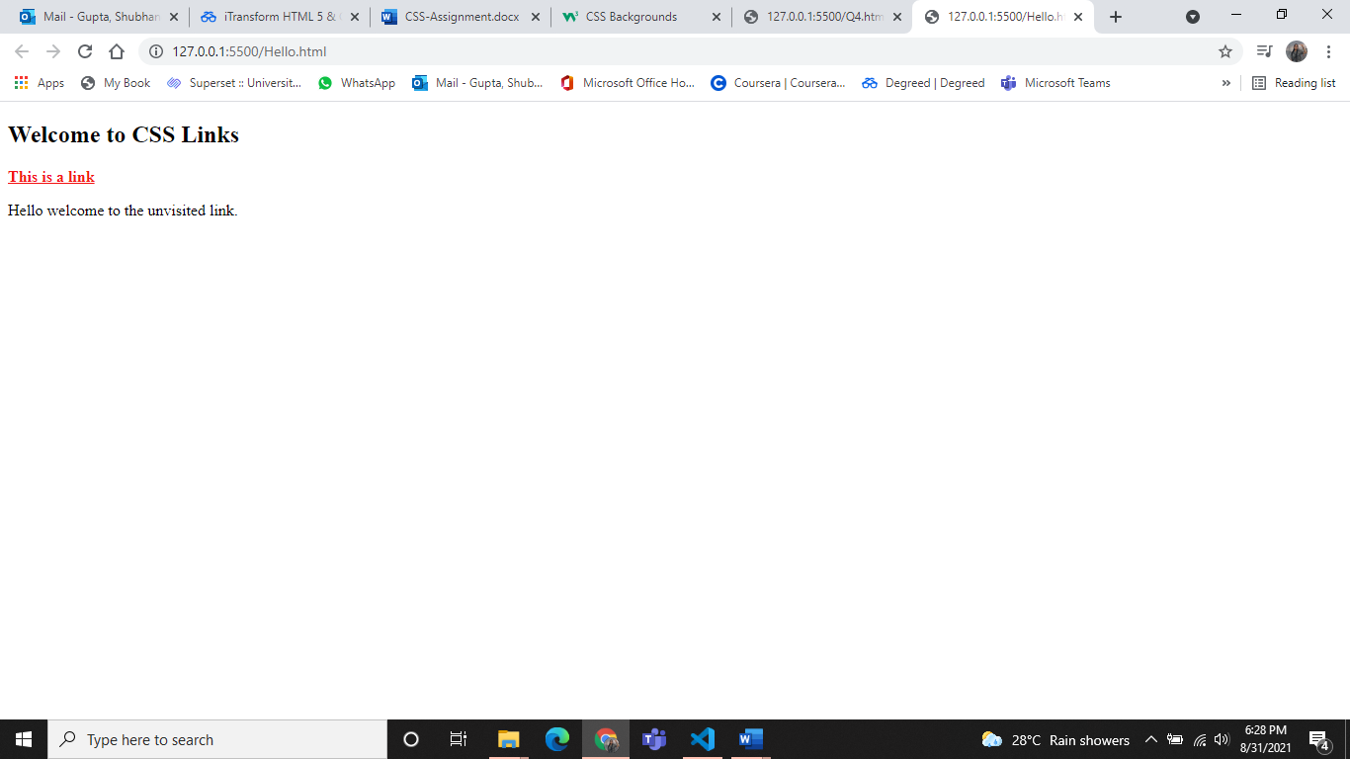

Q.5

<!DOCTYPE html>

<html>

<head>

    <style>

        table,

        td,

        th {

            border: 1px solid black;

        }

        table {

            width: 10%;

            border-collapse: collapse;

        }

    </style>

</head>

<body>

    <table>

        <tr>

            <th>Firstname</th>

            <th>Lastname</th>

        </tr>

        <tr>

            <td>Shubhangi</td>

            <td>Gupta</td>

        </tr>

        <tr>

            <td>Lois</td>

            <td>Griffin</td>

        </tr>

    </table>

</body>

</html>

Output:

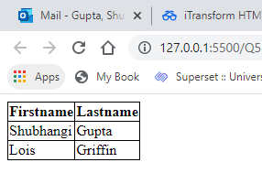

Q.6

<!DOCTYPE html>

<html>

<head>

    <title>CSS Question 6 </title>

    <style>

        table,

        th,

        td {

            border: 1px solid green;

        }

        th {

            background-color: green;

            color: white;

        }

    </style>

</head>

<body>

    <table>

        <tr>

            <th>Firstname</th>

            <th>Lastname</th>

            <th>Savings</th>

        </tr>

        <tr>

            <td>Shubhangi</td>

            <td>Gupta</td>

            <td>$100</td>

        </tr>

        <tr>

            <td>Lois</td>

            <td>Griffin</td>

            <td>$150</td>

        </tr>

        <tr>

            <td>Joe</td>

            <td>Swanson</td>

            <td>$300</td>

        </tr>

        <tr>

            <td>Cleveland</td>

            <td>Brown</td>

            <td>$250</td>

        </tr>

    </table>

</body>

</html>

Output:

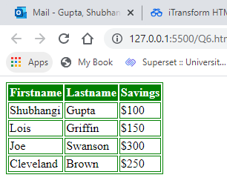

Q.7

<!DOCTYPE html>

<html>

<head>

    <style>

        p.c {

            border: 2px solid rgb(252, 43, 28);

            outline-style: dotted;

            outline-color: rgb(8, 247, 87);

        }

    </style>

</head>

<body>

    <h2>HTML page to set the outline-color</h2>

    <h2>

        <p class="c" <b>Note:</b> IE8 supports the outline properties only if a !DOCTYPE is specified.

        </p>

    </h2>

</body>

</html>

Output: 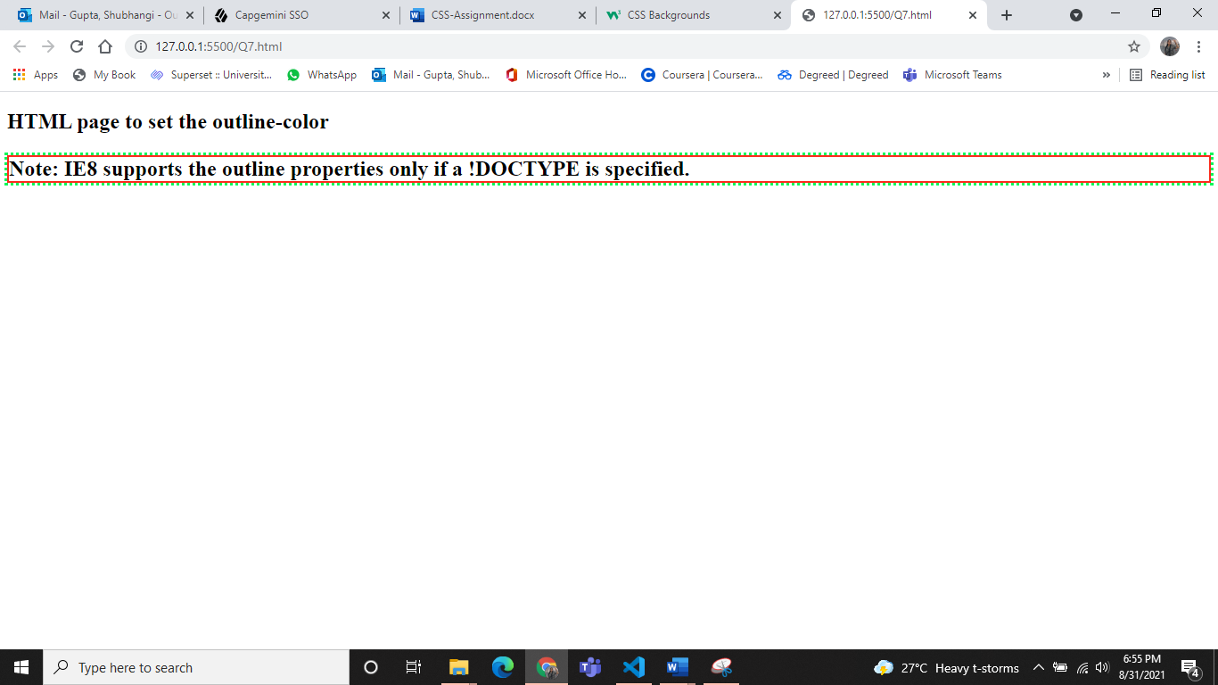

Q.8

<!DOCTYPE html>

<html>

<head>

    <style>

        body {

            background-color: #f7f7f7;

        }

        h1 {

            border-style: solid;

            border-width: 1ex;

        }

        h2 {

            border-style: solid;

            border-width: thick;

        }

        h3 {

            border-style: solid;

            border-width: medium;

            line-height: 1.6;

        }

    </style>

</head>

<body>

    <h1>Some Text.</h1>

    <h2>Some Text.</h2>

    <h3>Some Text.</h3>

</body>

</html>

Output:

